**RIPHAH INTERNATIONAL UNIVERSITY ISLAMABAD**



Lab # 03

Bachelors of Computer Science – 5th Semester

Subject: operating system

Submitted to: Mam kauser

Submitted by: Ayesha Akhter

Sap ID: 46508

**Task 1:**

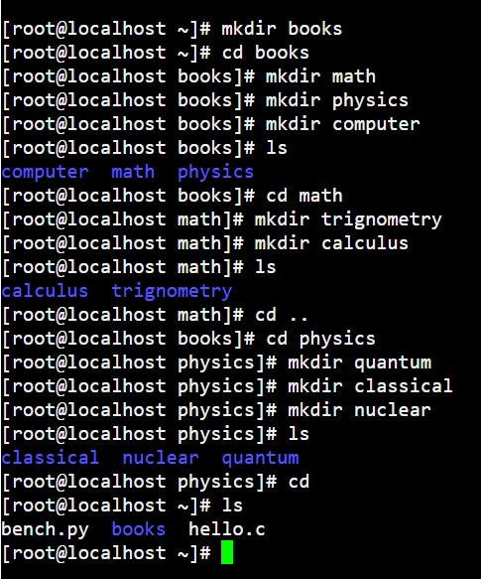

**Task 2:**

**Which are the Linux Directory Commands? Explain the understanding of commands in your own words. Also define what is BASH?**

Common Linux Directory Commands (Simplified)

pwd: Shows your current directory.

**Example**: pwd

ls: Lists files and directories in your current location.

**Example**: ls

cd: Changes to another directory.

**Example**: cd /home/user/Documents

mkdir: Creates a new directory.

**Example**: mkdir new_folder

rmdir: Deletes an empty directory.

**Example**: rmdir old_folder

rm -r: Deletes a directory and its contents.

**What is BASH**?

BASH (Bourne Again Shell) is the default shell in Linux used for running commands and writing scripts. It helps you interact with the system and automate tasks. You can customize it through configuration files like. bashrc.

**Simple script example:**

#! /bin/bash

cp /home/user/Documents/*.txt /home/user/Backup/

**Task 3:**

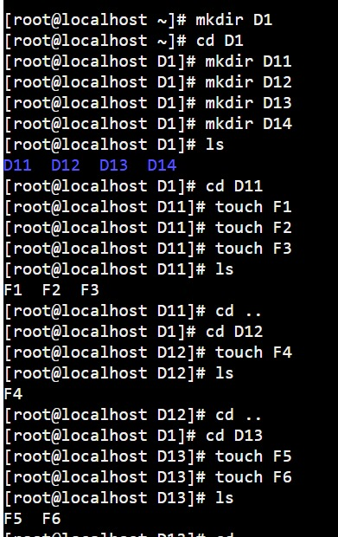

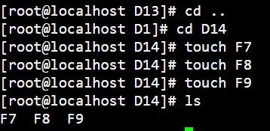

Task 4:

